1. Go to: <https://github.com/EmilyCBush>
2. Click on the repo, for example, “Force-System”
3. Click “Download ZIP” on the right side of the window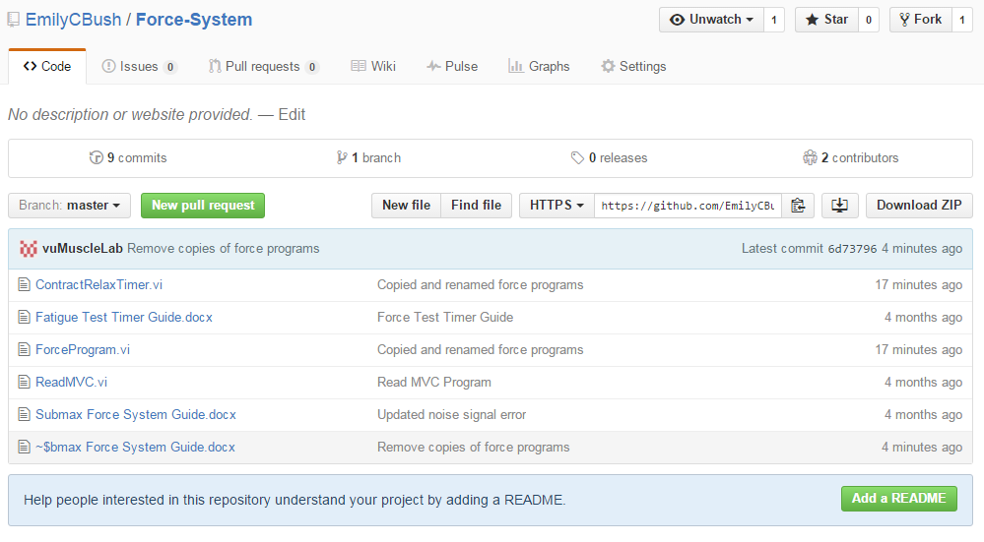
4. Find the .zip file in your downloads folder, unzip, and open the program you need